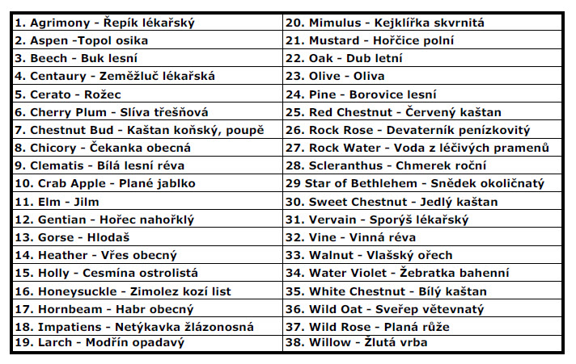
39. Krizová esence (Rescue remedy, 5 Flowers)
39. Krizová esence (Rescue remedy, 5 Flowers)

